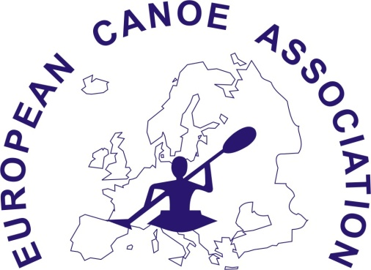

ECA PARACANOE
Waiver for PFD use

FEDERATION: ................................................................

ATHLETE COMPETITION NUMBER: ...........................
ATHLETE NAME: .............................................(please print)
I witness that I have excellent swimming ability, and not wearing a PFD at this competition presents no risk of personal injury or harm to myself. I will not hold the ECA, or the 2015 European Canoe Sprint Championship organizing committee or any of their representatives responsible for any harm or injury which may occur to myself as a result of not wearing a PFD
ATHLETE SIGNATURE: ................................................
I witness that this athlete has excellent swimming ability and not wearing a PFD at this competition presents no risk of personal injury or harm to him/her. We will not hold the ECA or the 2015 European Canoe Sprint Championship organizing committee or any of their representatives responsible for any harm or injury which may occur to this athlete as a result of not wearing a PFD.
TEAM LEADER: ................................................ (please print)
TEAM LEADER
SIGNATURE: ...........................................................

